Practical No. 13
Aim : Configure static IP address in operating system along with appropriate subnet mask for given problem

Name : Danish Altaf Solkar | Class : CO - B
Enrolment no. : 24111590805 | Batch : 2

- Open Control panel
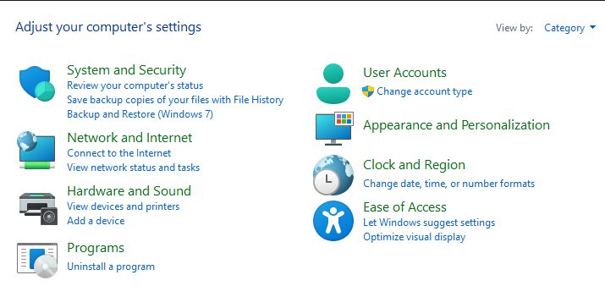

- Open Network and Internet
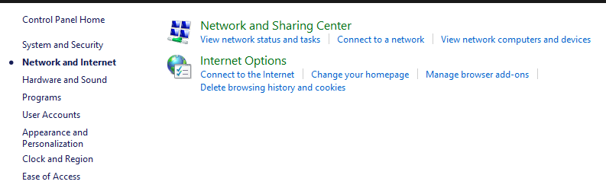

- Open Network and Sharing Center
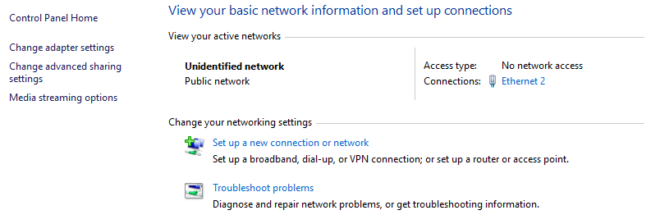

- Open Change Adapter settings
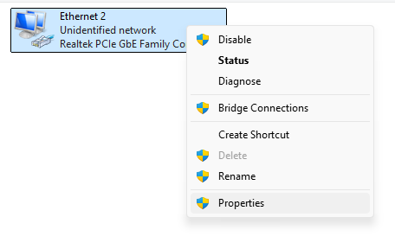

- Right click on Ethernet and open properties
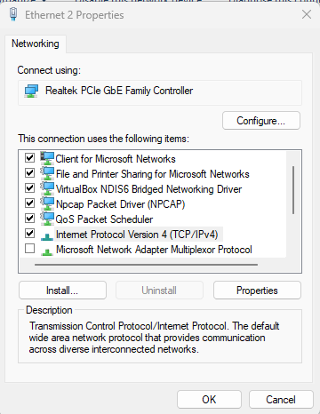

- Click on Internet Protocol Version 4 and open properties
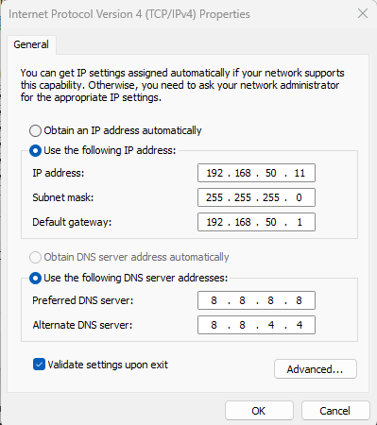
- Open Command Prompt
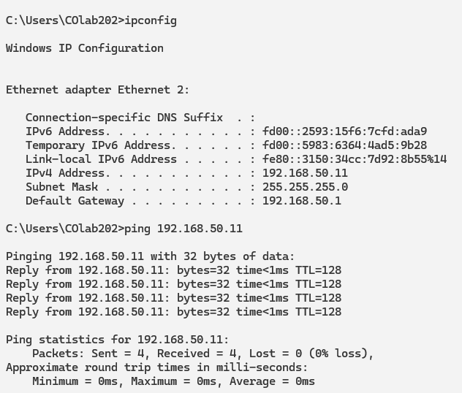

- Ping another device in same network
